Request for Proposals

Website Design and Development

Bemidji State University

August 13, 2025

# Summary

The primary objective of the Bemidji State University (BSU) website design and development project is to enhance the user experience and align with our evolving brand identity and business goals. Our current web presence is functional but cannot meet the expectations of our target audiences or support our strategic initiatives effectively within our desired timeline without external partnership to guide and implement more comprehensive website upgrades.

Website design work with internal and external expertise is a strategic investment in BSU’s digital presence. We are seeking a website design and development partner with comprehensive experience working with higher education clients, extensive digital marketing expertise, and a design-for-the-future mindset.

Key Proposal Dates

* August 27, 2025 – Deadline for prospective vendor questions
* September 3, 2025 – Vendor questions answered by BSU
* September 10 , 2025 – Deadline to submit proposals (11:59 p.m., Central Time)
* September 11 - 26, 2025 – Finalists selection and presentations
* October 1, 2025 – Partner selection
* October 15, 2025 – Project kickoff
* July 15, 2026 – Phase 1 Launch (For External Audiences)
* TBD – Phase 2 Launch (For Internal Audiences)

Vendor Review and Selection Team

* Amy Meckeler – Interim Executive Director of Communications and Marketing
* Marie Bock – Interim Chief Information Officer
* Maggie Zebracka – Project Manager, Office of Communications and Marketing
* Jo Domogalla – Web Content Manager, Office of Communications and Marketing
* Brad Folkestad – Assistant Director, Enrollment Marketing Specialist
* Kody Hagen – Lead Web Developer
* Jason Raveling – Web Developer
* Shane Jensen – IT Specialist
* Dan Voss – Director of Academic Partnerships

BSU will select the vendor(s) whose proposal(s), and interviews/presentations, if requested, demonstrate the clear capability to best fulfill the project outlined in this Request for Proposals (RFP). BSU reserves the right to accept or reject proposals, in whole or in part, and to negotiate separately as necessary to serve the best interests of the university. The RFP shall not obligate BSU to award a contract or complete the proposed project, and it reserves the right to cancel this RFP if it is in BSU’s best interest to do so.

# About Bemidji State University

On the idyllic shores of Lake Bemidji, cradled among the limitless natural beauty of the North Woods and neighbored by Minnesota’s three largest Indigenous nations, Bemidji State University (BSU) offers opportunities for the extraordinary.

Bemidji State University has been ranked as one of the top 30 public institutions in the Midwest region by U.S. News & World Report each year since 2019. BSU offers its diverse student body a comprehensive spectrum of opportunities with more than 120 undergraduate degrees and emphasis areas in 55 areas of study, 14 pre-professional programs, and 13 graduate programs and certificates.

As Bemidji State continues its second century of service, our vision is simple: we educate people to lead inspired lives. To achieve this, BSU strives to create a campus culture in which all members are free to be their authentic selves. BSU offers accessible, affordable, high-quality educational opportunities for around 4,100 students each year.

BSU is a member of the Minnesota State system of colleges and universities, the third-largest system of higher education institutions in the United States. It shares a unique alignment with Northwest Technical College (NTC), with administration and student services generally having dual responsibilities to serve both campuses. Through this alignment, NTC students can take advantage of services, support, activities, and opportunities at BSU that expand and enhance their college experience — such as full access to BSU’s library and the ability to live in BSU’s on-campus resident housing. Both BSU and NTC are accredited by the Higher Learning Commission (HLC).

Phase two of a joint strategic planning process – launching in October of 2025 – will guide the future directions for both institutions. In phase one (2023 to 2025) the schools have prioritized four shared strategic priorities: student success, the Nisidotaading initiative, northern distinction (in partnership with the City of Bemidji and a region spanning 200 miles to the north, 140 miles to the east and south and 100 miles to the west), and telling our story. These priorities will serve as foundations for master planning processes for facilities, academic programs, fundraising, information technology, intercollegiate athletics, and diversity, equity, and inclusion, among others.

The Nisidotaading initiative — named for an Ojibwe phrase meaning “building mutual understanding” — is creating a statewide center of excellence. It will develop communities of practice meant to help Minnesota State colleges and universities better educate their campus communities on historical trauma and lived experiences of their Indigenous populations, and how to most effectively guide Indigenous students toward their educational goals. In addition, BSU is the first university in the United States to expose all of its students to a course on Indigenous people before graduation.

Key Competitors

* University of Minnesota, Duluth
* Minnesota State University, Mankato
* Minnesota State University, Moorhead
* North Dakota State University
* Minot State University
* University of North Dakota
* St. Cloud State University
* Lake Superior State University
* University of Minnesota, Twin Cities
* Other regional public universities – Iowa, Wisconsin, North Dakota
* Other DII universities in Northern Sun Conference (other DI for hockey, Central Collegiate Hockey Association)

Current Status of BSU Branding

BSU will soon reignite a brand refresh to finalize minor updates to its brand portfolio. The website design and development work will require some integration of the brand refresh work – eg, typography, logo, wordmark, graphic elements, and messaging framework. We expect to restart the branding enhancement work sometime in November (2025) – January (2026).

# About Our Current Site ([bemidjistate.edu](https://bemidjistate.edu))

BSU’s website, [bemidjistate.edu](https://www.bemidjistate.edu/), is the digital gateway to Bemidji State University. The site is a vital component of the university’s communications and marketing strategy as well as investments to support student success and retention, internal and external audience engagement, and overall public perception.

## Website Environment

CMS platform: BSU’s digital presence is built and maintained using a WordPress multisite network subdirectory configuration.

Hosting: BSU’s websites are hosted on-premise within our own infrastructure.

Theme framework: Website designs are implemented by BSU Web Services using MDBootstrap Standard Pro. Both BSU and NTC heavily leverage the theme framework to deliver content and functionality to our enterprise web applications, tools, and services.

Target audiences: Prospective learners and their influencers; Current learners and the faculty/staff who educate and support them; Alumni, donors, industry, and community partners.

Governance: Evolving to a centralized model. As of 7/5/25, there were 72 users in WordPress. Through a manual removal, the number will drop to below 54 users prior to the redesign. Website training is a priority, though time constraints and our de-centralized model make it difficult to create and facilitate. We are also committed to improving our web editing request ticketing system to be intuitive, helpful, and user-friendly from request through delivery.

## Site Metrics and History

The BSU2014 theme design was originally created by White Whale and implemented by BSU Web Services. In 2020, BSU Web Services implemented graphic identity work that Adventure Creative designed for BSU, which included new logos, design elements, and a secondary color palette.

Content audits have been ongoing based on need and capacity. In 2022, BSU began migrating sites from our "2014 theme" to the updated "2021 theme," both of which use the classic WordPress editor. In 2024, a second migration began from the classic editor to Gutenberg.

### Site Size

BSU has 159 sites totaling approximately 2,009 pages. Many pages may contribute to content overload and navigation issues. (NTC’s site has approximately 501 pages.) This page count does not include over 4,000 news articles and custom post types. The web team is currently discussing archiving old news articles.

Analytics

Traffic Trends: the BSU .edu homepage and “mybsu” are top pages. Ideally, the Find-Your-Program tool would outperform the Academics landing page. Notably, there are high bounce rates on pages that we expect users would spend more time on (i.e. Financial Aid). Top pages and metrics over 28 days are included in the table below.

|  |  |  |  |  |
| --- | --- | --- | --- | --- |
| **Page title** | **Views** | **Sessions** | **Avg engagement time per session (min:sec)** | **Bounce rate** |
| **Totals** | **272304** | **68274** | **01:42** | **29.74%** |
| MyBSU | 66507 | 29458 | 01:03 | 17.75% |
| Bemidji State University (homepage) | 26775 | 19274 | 00:16 | 22.18% |
| e-Services Login | 15139 | 11334 | 00:05 | 5.66% |
| Course Schedule | Academics | 8708 | 2898 | 03:33 | 9.01% |
| Academics | 5649 | 3893 | 00:19 | 2.57% |
| Find Your Program | Academics | 4538 | 3220 | 01:19 | 3.94% |
| Admissions | 3066 | 2279 | 00:19 | 7.33% |
| Apply | Admissions | 2976 | 1828 | 00:27 | 10.83% |
| Online Application (undergraduate) | 2679 | 857 | 00:18 | 2.80% |
| Directory | 2122 | 1728 | 00:32 | 3.36% |
| Student Life | 1751 | 1370 | 00:19 | 2.70% |
| About | 1587 | 1332 | 00:28 | 4.80% |
| Academic Calendars | Office of Academic Affairs | 1351 | 1197 | 00:10 | 31.33% |
| Directory (facstaff) | 1240 | 658 | 00:58 | 3.50% |
| Directory (offices) | 1227 | 809 | 01:15 | 2.47% |
| Online Application | 1178 | 415 | 00:07 | 4.34% |
| Parking Permits | Public Safety | 1176 | 864 | 01:26 | 13.66% |
| Library | 1136 | 854 | 00:21 | 9.72% |
| Employment Opportunities | Human Resources | 1018 | 904 | 00:20 | 27.88% |
| Online Application (graduate) | 1000 | 315 | 00:13 | 0.95% |
| Financial Aid | MyBSU | 973 | 719 | 00:50 | 12.24% |
| Housing & Residential Life | 927 | 761 | 00:20 | 5.78% |
| Request More Information | Admissions | 876 | 695 | 01:00 | 3.31% |

Top pages and metrics over 28 days

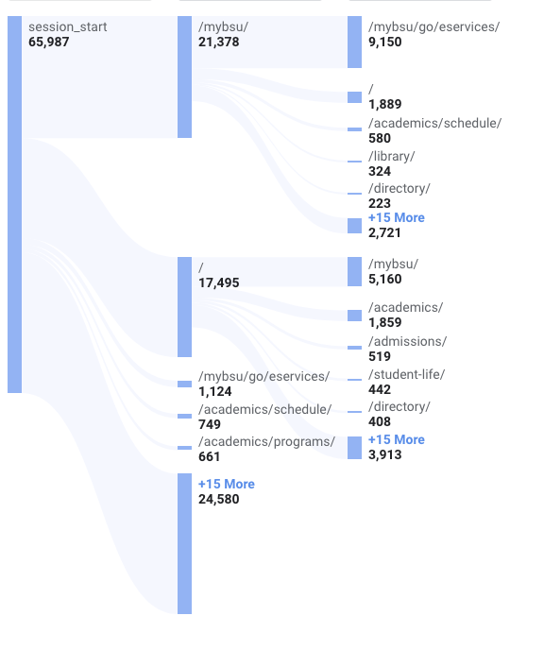

User path exploration over 28 days

Search Behavior: Most users arrive via organic search.

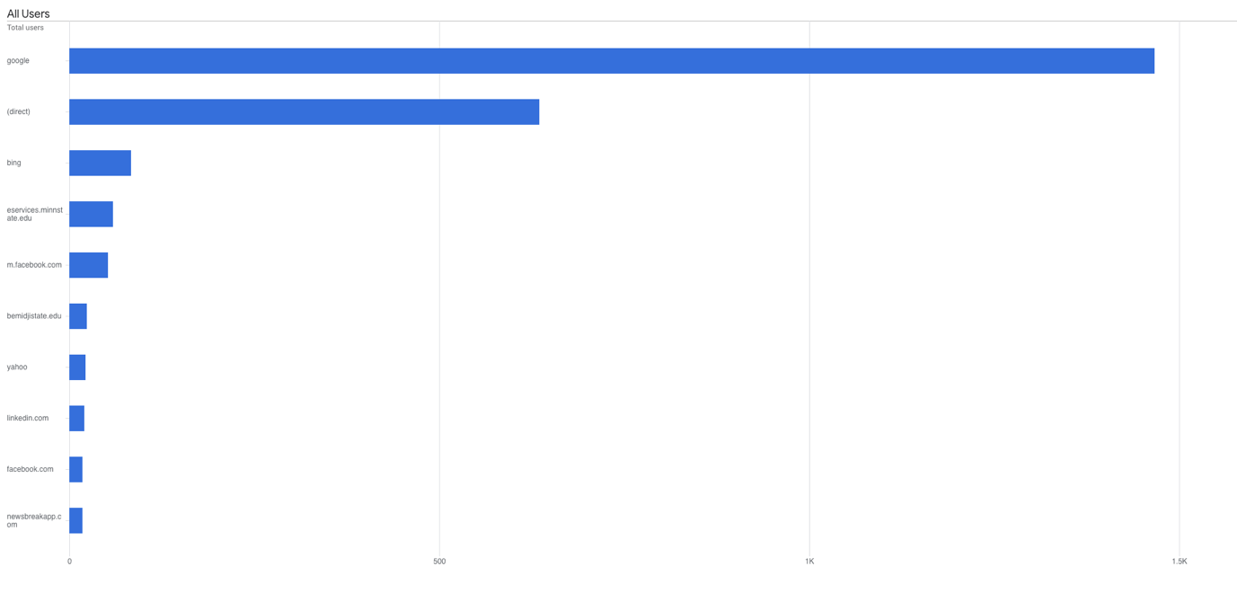

User traffic sources over 28 days

## Website Pain Points

### Content Challenges

* Too Much Content: Redundant, outdated, and trivial information overwhelms users.
* Internal vs. External Information: Lack of clarity between what’s meant for internal audiences vs. external visitors.
* Content Visibility: Difficulty in surfacing priority content (e.g., new tools like Find Your Program, academic pages.)

### Navigation Structure

* Top Navigation Issues: Overloaded and not intuitive, making it hard for users to find what they need.
* Header Complexity: Multiple navigation bars create confusion.
* Link/Button Clarity: Inconsistent styling makes it unclear what is clickable.
* Duplication: Repeated links and visual inconsistency reduce usability.

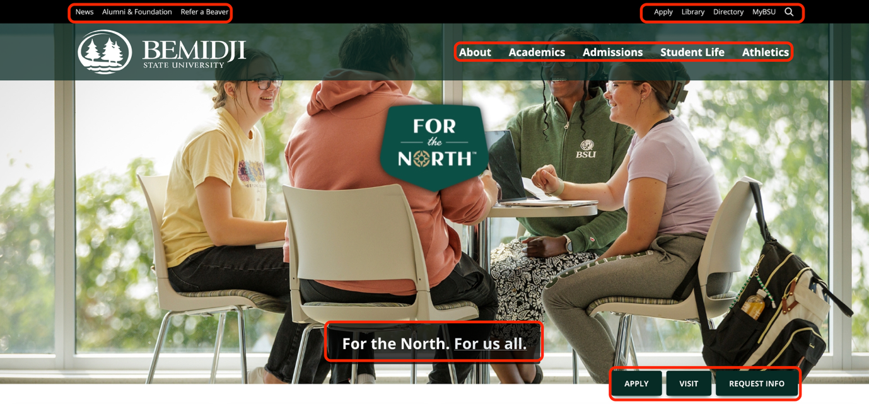

Highlighted areas of navigation and link structures

### Page Layout and Design

* Title-to-Content Gap: Excessive spacing between page titles and actual content.
* Hero image: The title of a page is often over a hero image, making it hard to read.
* Header font: Ideally, our header fonts would be sans serif and match our paragraph text typography.
* Page Identity: Users often don’t know what page they’ve landed on.
* Left Navigation: This navigation menu helps in some regard, but we look forward to layout enhancements that will also help with facilitation.

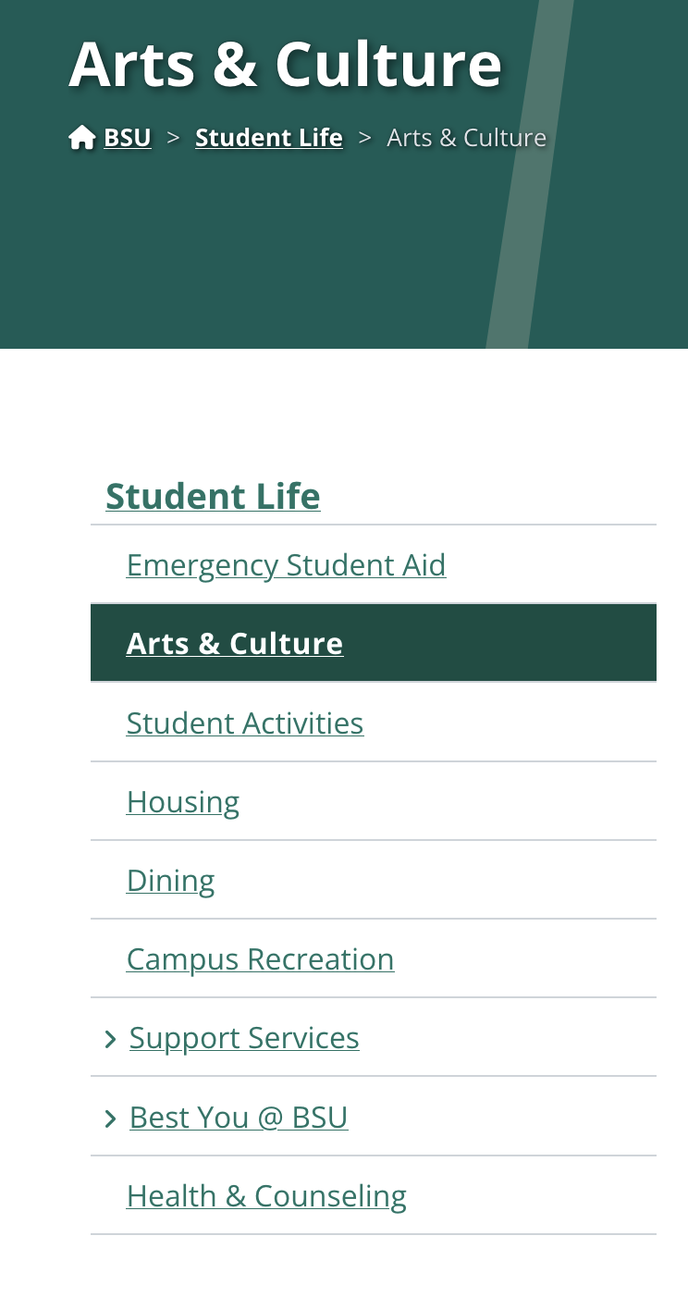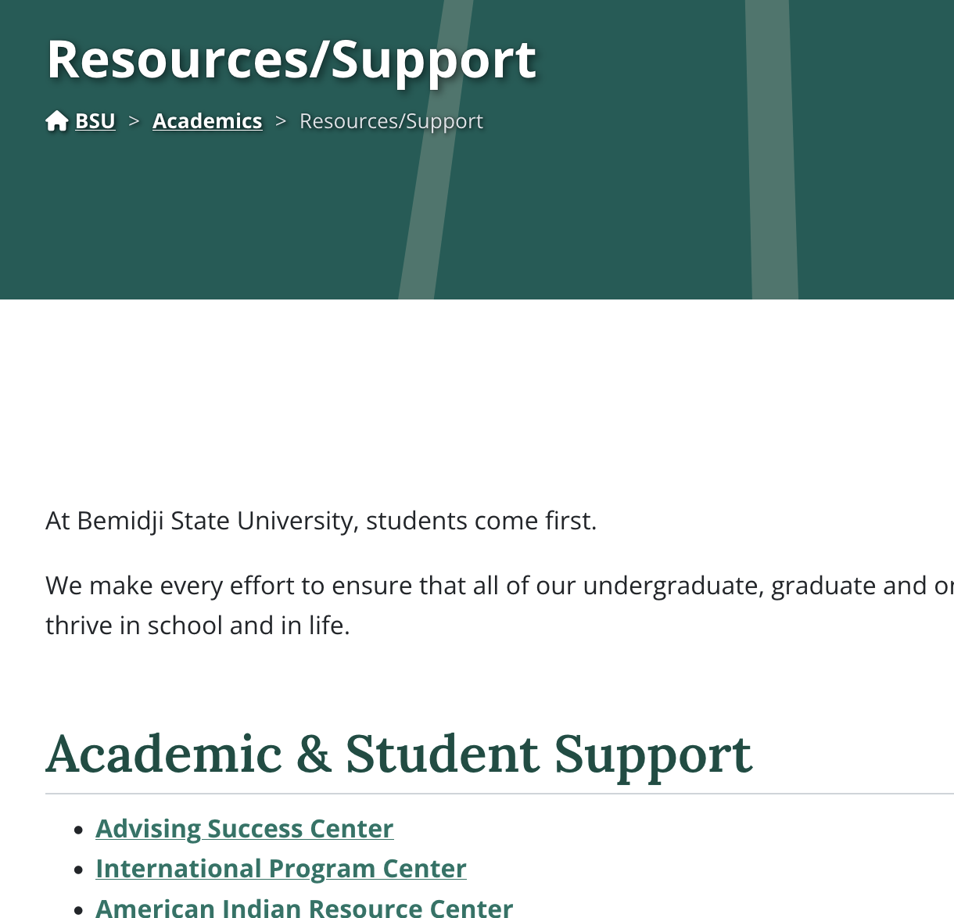

Content pages with and without left navigation structure

# Project Goals

The primary objectives of the Bemidji State University (BSU) website design and development project is to enhance website user experience, align with our evolving brand identity, and ensure that our web presence performs efficiently to meet our strategic institutional priorities. As such, we are focused on meeting the following, integrated project goals:

* Improved User Experience (UX) – external and internal users
* Search Engine Optimization (SEO) – organic
* Attractive User Interface (UI) – aligned with university identity and branding
* Optimized facilitation
  + Navigation elements (menus, breadcrumbs, search functionality)
  + Content elements (text, images, videos, typography, graphics)
  + Interactive elements (buttons, forms, call-to-actions)
  + Structural elements (layout, grid systems, whitespace)
* Improved content strategy
* Well-structured semantic content and html
* Optimal load time
* WCAG 2.2 AA standards for accessibility as well as Section 508 compliance
* Training and support as determined by the core project team
* Performance-focused analytics and monitoring
* Upgraded and enforceable governance model
* Systems integration – to some degree
  + SIS
  + CRM
  + Required Reporting – Title IX, Hazing, Safety, etc
  + Enterprise resources
  + Google Analytics, SemRush, Siteimprove
  + Forms
  + Directories
  + Calendar
  + Admissions applications, RFI and associated landing pages, etc
  + News, blogs, etc

# Project Scope

* Pre-project research and discovery – some parameters and expectations include:
  + BSU’s identity and “special sauce” – why do people attend and support BSU?
  + The purpose of the site
  + SWOT Analysis
  + Site audiences and archetypes
  + Pain points and expectations
  + Site audit – scaled to project goals
  + Top-level site needs (functionality, editorial, content model)
* Top-line brief and project plan, including project management system
* New site map – prioritizing external audiences in Phase 1 while respecting internal audiences and planning for Phase 2
* Wireframes
  + Home Page
  + Standard Use Page
  + Pages Associated with “Find Your Program”
  + Unique Landing Page and Design Blocks
  + Forms and Lead Capture
  + Academic Catalog Landing Page
  + Directory and Bios – Individual Posts
  + News Feed, News Category Feed, and Articles
  + Calendar Feed, Calendar Category Feed, and Articles
  + Profiles/Testimonials Feed, Profiles and Testimonials
  + Scholarship Feed and Scholarships
  + Curative and Automated Related Content
  + Facilitation Types
  + Glossary
  + Site A-Z List
  + Call-to-Action Blocks
  + Image and Gallery Blocks
  + Video Blocks
  + Campus Alerts
* Advanced site search
* SEO improvements/recommendations
  + Selection and placing of keywords
  + Page titles and meta descriptions
  + Headings, subheadings, contextual links and calls to action
  + Other
* UI and CMS development and implementation
* Content development – for key areas of the site
* Governance model recommendation and rationale
* Plan for Phase 2 - distinct intranet for faculty and staff
* QA testing
* Post-launch support
* Workshops and training

# Out of Project Scope

* Athletics website
* NTC website
* Alumni and Foundation website
* Academic catalog

Timeline

Phase 1 - nine (9) months, from project kick-off to launch

Phase 2 – nine (9) months or less, from project kick-off to launch

Budget

$200,000 Phase 1 and 2 combined

Project team

* Website Design Project Leads for the overall project
  + Amy Meckeler (Main Contact) - Interim Executive Director of Communications and Marketing
  + Maggie Zebracka - Project Manager, Office of Communications and Marketing
  + Jo Domogalla – Web Content Manager, Office of Communications and Marketing
  + Marie Bock – Interim Chief Information Officer
  + Kody Hagen – Lead Web Developer, Information Technology
  + Jason Raveling – Web Developer, Information Technology
* Website Content Managers for departments/units/divisions - TBD
* Extended Team - TBD