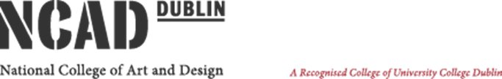

15th September 2025
To whom it may concern,

The National College of Art and Design (NCAD wishes to invite tenders for the Provision of Website Design, Website Development, Hosting, Support and Maintenance of its website.
Please note that whilst considering your application, at least one project you worked on must relate to developing a website related to organisations supporting and/or operating in an artistic / creative environment is required.
The Request for Tender consists of the following two Lots
- Website Design (crafting the Visual and User Experience), Support, Maintenance & Hosting

- Layout & Structure
- Colour Scheme & Typography
- User Experience (UX) Design
- Responsive Design
- Visual Hierarchy
- Consistency
- Imagery & Graphics

- Web Development (bringing designs to life)
- Front-End Development
- Back-End Development
- Full Stack Development
- Collaboration and Workflow
Kindly note that Tenderers may tender for Website Design (Lot 1), Website Development (Lot 2) or both.

The Closing date for receipt of tender submission is the 15th of October 2025.
Kind regards
Jenny Kavanagh
Jenny Kavanagh
Procurement Administration NCAD

